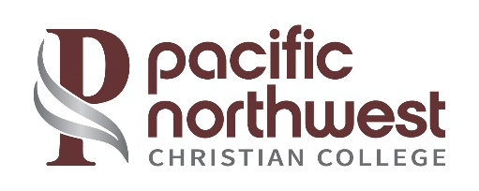

Pacific Northwest Christian College Retention Rates*

Program | 2022-2023 | 2021-2022 | 2020-2021 | 3 Yr. Average
Associate | 51% | 50% | 89% | 63%
*Retention rates for an associate’s program are fall-to-fall (includes previous spring) based on first-time, full-time status

Pacific Northwest Christian College Graduation Rates**

Program | 2019 Cohort | 2018 Cohort | 2017 Cohort | 3 Yr. Average
Associate | 51% | 61% | 38% | 50%
** The completion/graduation rates for associate degrees are measured at 150% of the expected time for completion (the associate degree rate is 3 years from the first enrollment).

Pacific Northwest Christian College Transfer-Out Rates***

Program | 2019 Cohort | 2018 Cohort | 2017 Cohort | 3 Yr. Average
Associate | 9% | 0% | 7% | 5%
*** These are students who transfer before they complete their associate’s program at PNWCC within 3 years of enrollment. The transfer-out rates for associate degrees are measured at 150% of the expected time for completion (the associate degree rate is within 3 years from the first enrollment).

